Shahab Siddiqui

English 101

Prof. Pilotte

11/11/19

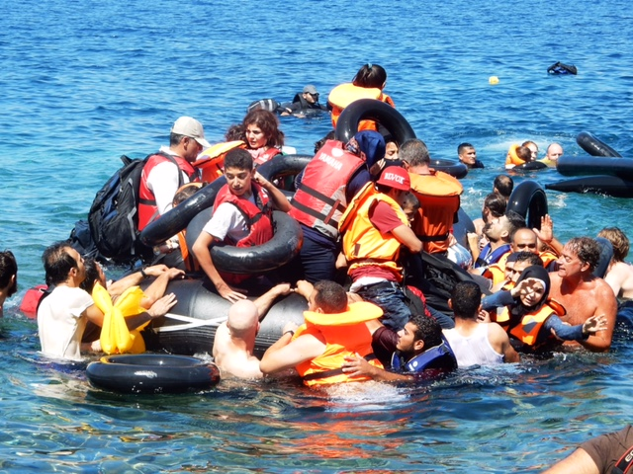

The World Refugee Crisis

A ten-year-old girl says” They were dying all around us, asking for help but we couldn’t help them.” Her name is Hiba Nabulsi and she is a refugee. She was forced to leave Syria. Then she went to Turkey. From Turkey she took a boat. There the boat deflated. She spent 2 hours at sea. After being rescued by a plane they were smuggled to Greece. Where she finally reached a refugee camp. Now she is in the camp and she misses her sisters, but she misses her brother the most who is now dead. This is Hiba’s story she is only ten and she has seen worse things than many ever see in their whole life. The world refugee crisis is growing, in order to understand it is important to know who the refugees are, what made them refugees, and how they are being treated.

In order to understand the world refugee crisis, it is important to know who the refugees are. Refuges are normal people that live through abnormal time. Refugees are forced to flee their homes due to persecution, war or violence. Refuges are not in their own country. They are at risk because of nationality, race, sexual ordination, religion, social group or political opinion. They put into jails and beaten because of these things. Often refuges leave with only the clothes they have on. They leave their homes, savings and family. During the journey for asylum, they face many challenges. Many lose their life’s. International laws protect refugees. Refugees cannot be sent back to their counties if they are at risk. Counties have a legal obligation to let refugees in and protect them. The world has a lot of misconceptions about the refugees. Some people believe that all the refugees are terrorists. Holpuch says” ...none of the more than 3 million refugees resettled since 1980 have committed a lethal terrorist attack.” (1). There is no connection between being a refugee and terrorism. It is simply a misconception. Another misconception regarding the refugees is that refugees go to other countries because of economic benefits. As shown in This is Home: A Refugee Story upon arriving to their new home the refugees must say yes to any job that is offered to them. They are most often forced to work minimums wage jobs. Even if they can go other jobs. Such as one of the men from the movie was mechaanic He still had to work a minimum wage job. He had no economic benefit in leaving his job as a machine and working a minimum wage job. The is simply is a misconception about the refugees.

In order to understand the world refugee crisis, it is important to know what made them a refugee. There 3 main reason why refugees become refugees are persecution, war or violence.

67% of all refugees came from 5 countries. Another country is Syria. Syria has now been at war for 8 years and it is getting even worse. The peaceful protest turned into a civil war. They people involved in Syria are President Assad, the rebels, in the north are the Kurds who are backed up by the United States, Turkey, Israel and Islamic State group. President Assad since he’s been in power has had one goal which is to stay in power. The President is fighting with the rebels. While the US is fighting IS and Israel is fighting Iran. The reason that Syria is such a mess is because it has become a proxy war for international power. With all of these nations involved, what can the people of Syria do but to seek asylum. Another country is Afghanistan. Afghanistan has a lot of the US army this due to 9-11. The group that was responsible for 9-11 was in Afghanistan. Since than the US has been in Afghanistan fighting the Taliban and other terrorist groups. This has created all-out war in Afghanistan in which the people of Afghanistan are suffering. They are in the middle of a war that does not have anything to do with them. These incent people have no other choice but to seek asylum. Another country is Sudan. President Omar al-Bashir was forced out of power after ruling for 30 years. There now former President committed many war crimes. The people protested for over a month and military took over and forced Omar al-Bashir to step down, but all of these things were as simple as this. This is a full-on revolution. Also, in South Sudan there has been a civil war happening for 5 years. There have been almost 400,000 deaths since the civil war. The ongoing civil war has made it impossible for the Sudanese people to live in peace thus they must seek asylum. Other Country is Myanmar. It is been one of the longest running civil wars. The people of Myanmar to not support there government thus they have made there owns armies. This has created a war on the people of Myanmar. This leads the people of Myanmar to seek asylum. The fifth country is Somalia.

In order to understand the world refugee crisis, it is important to know how they are being treated. In the book Threads, constantly shows that the camps being low on supplies. Even when they have supplies, they run out very fast. The refugee’s homes were made of weak materials. The government created homes for them but they home where shipping containers and the people often had to share homes with other refugees. Living in a shipping container is inhumane. When a home was finally was found for the refugees. Then another battle is started for them. They are sent to new country in with they cannot speak the language. They do not the culture and have to adapt and they have to adapt fast. Some countries do not want refugees in their county. Germany being a big home. The leader of their movement against refugees says, “Islam is not a region it is a fiscally ideology.” (ABC). The refugees sent to countries such as Germany will have an extremely hard time. They will not be accepted by the people of that country. Which is the reason that many try to make it back home. There are 41.3 million people are internally displaced around the world.

The world refugee crisis is growing, in order to help deduce the word refugee crisis the individuals, businesses and communities must come together. They must step forward and make a difference. As an individual, a person can help refugees integrate in their new community. With early support refugees can part of society quickly. A person can help them practice their English and they need to get to know the local community or culture. As a business, hire a refugee or even just offer them an interview. The refugees have the drive to succeed. Lastly, it is important to stand with the refugees. The refugees are being targeted by hateful views and just plain racism.

Work Sited

BBC News, director. *Syria: Seven Years of War Explained - BBC News*. *YouTube*, YouTube, www.youtube.com/watch?v=CoL0L_DbuQQ.

Evans, Kate. *Threads: from the Refugee Crisis*. Verso, 2017.

Shiva, Alexandra, director. *This Is Home: A Refugee Story*. *This Is Home: A Refugee Story*, 2018.

UNHCR Teaching About Refugees, director. *Who Is a Refugee?* *YouTube*, YouTube, www.youtube.com/watch?v=GvzZGplGbL8.